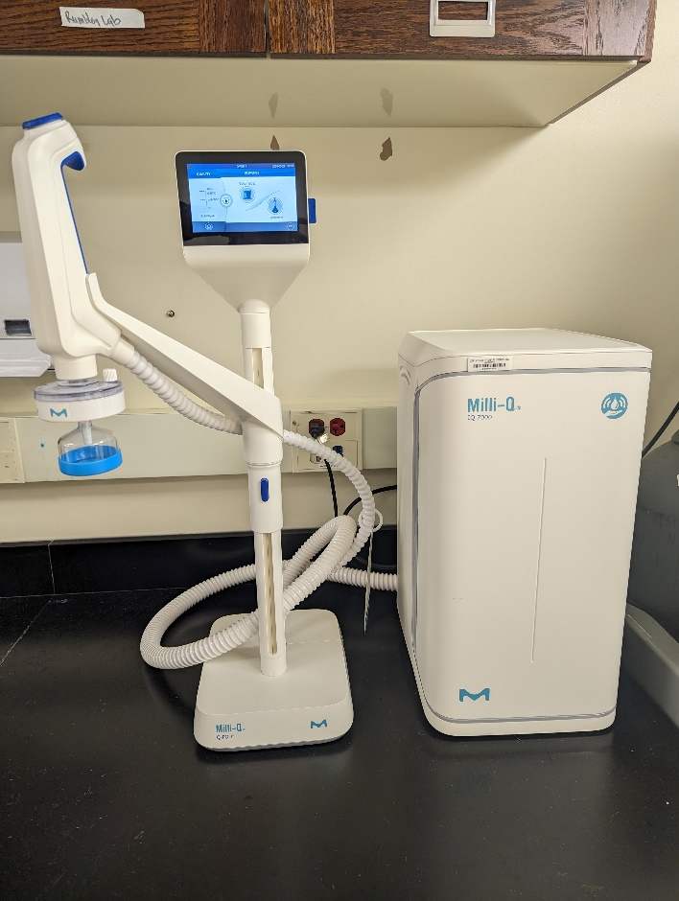
Instrument
Ultrapure water purification system
Model / Number
IQ-7000
Manufacturer
Millipore Sigma
Location
Life Sciences 250E
Instrument Description
This water purification system delivers reagent grade water that exceeds ASTM type 1 standards. Fit with a touch screen that displays real time TOC levels and water temperature, and two dispensing modes, you can get precise drop by drop delivery or up to 2 L/min flow rate. This particular machine is fit with a single dispensing arm the standard Millipak Gold final filter, but additional arms and filtration packs can be added to fit your laboratory needs.
User Charges
Not applicable
User Information
User must have key card access to Life Science 250. User must be trained to use this equipment. The user is responsible for cleaning and performing any per use maintenance, and providing any disposable supplies required for operation. Any damage caused by the user is the responsibility of the user to repair or replace.

