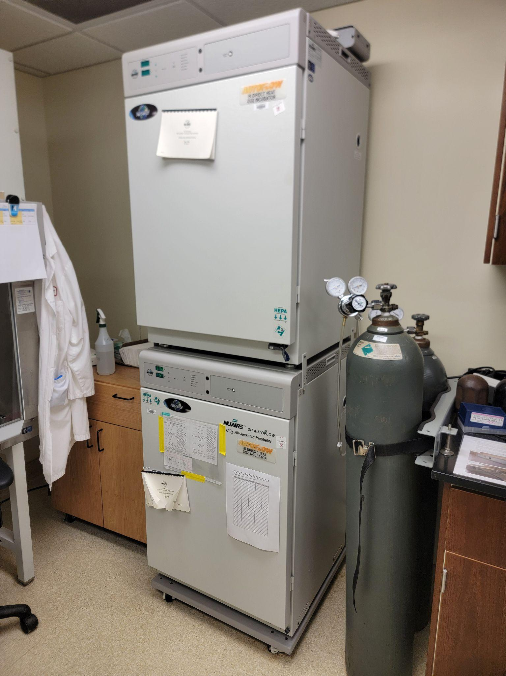
Instrument
CO₂ Incubator
Model / Number
Nuaire NU-5500
Manufacturer
Nuaire
Location
Life Science 250E
Instrument Description
All incubators are air jacketed, IR sensor CO₂ control, stacked, and on rolling platforms.
User Charges
Not applicable
User Information
User must have key card access to Life Science 250. User must be trained to use this equipment. Any damage caused by the user is the responsibility of the to repair or replace. These incubators may not be generally available. Bloodborne pathogen training is required before use.

